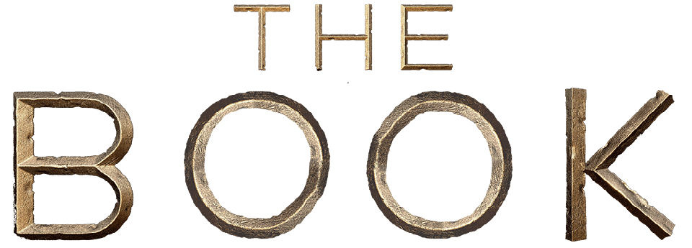
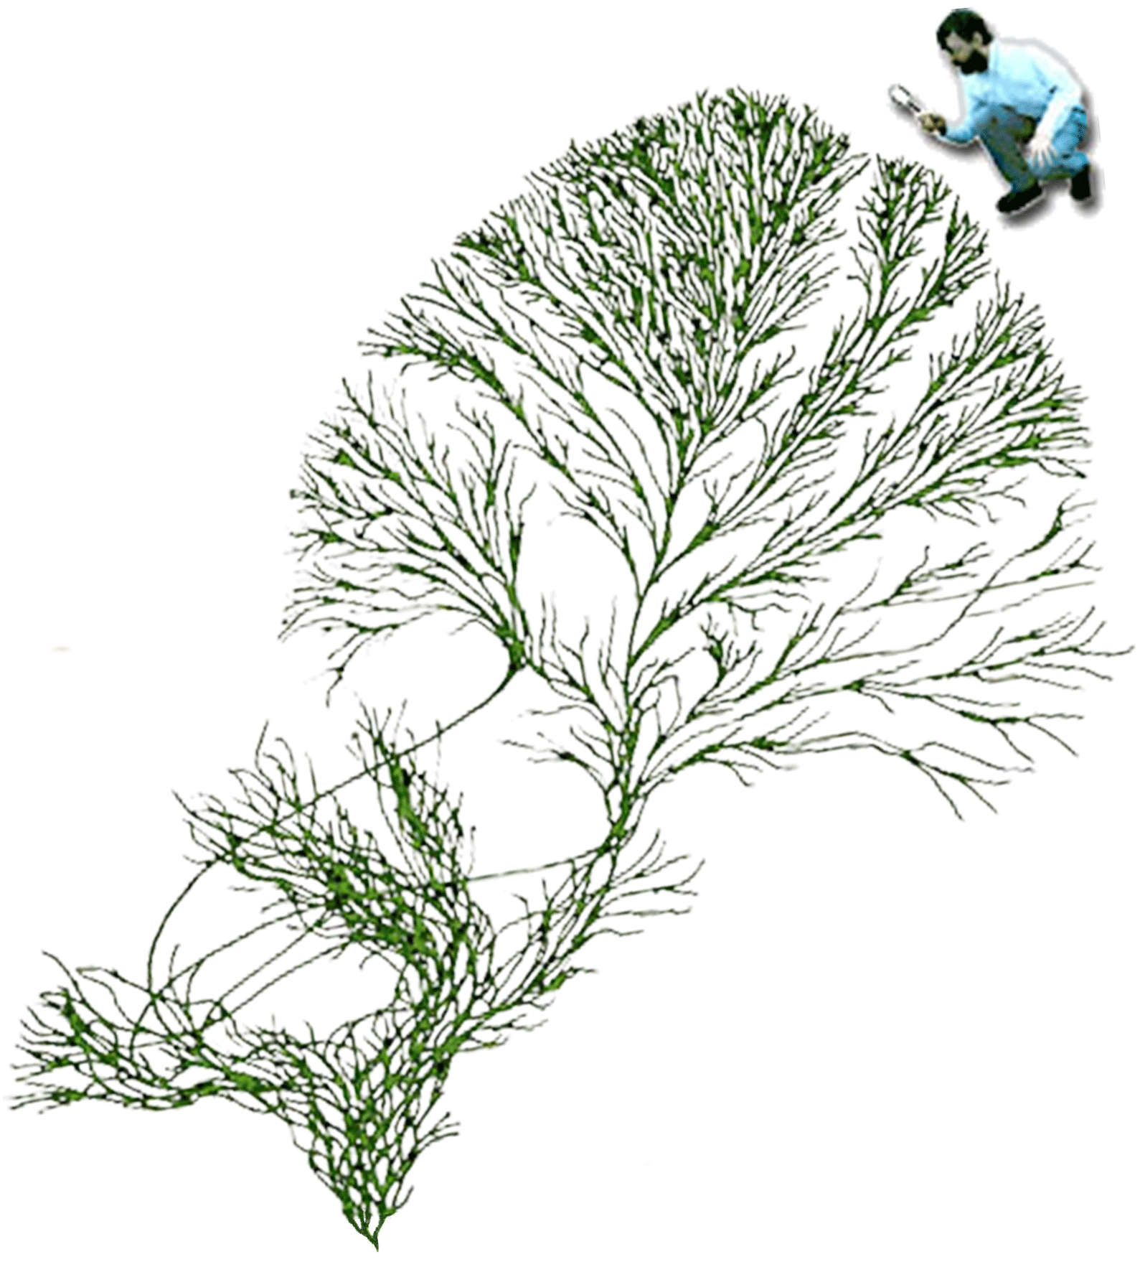
Chapter 1
The Ascent of Life

- In the beginning was the inflation from which light cameth as did the particles—from which all stars, quasars, galaxies, clusters of galaxies, superclusters, planets, moons, dust, and organisms did form.
- In a galaxy, one among billions, from the dust of first generation stars, did arise Sol having a Class M planet upon which an abiotic replicator begat more like unto itself, evolving into deoxyribonucleic acid, which did bioticly replicate more like unto itself.
- With genes did information come into being, a thing new under the sun, and its value grew over the eons—know thee the sanctity of information.
- And Lo, there were rays from the heavens, and mutation came to pass with error correction. And the deoxyribonucleic acid begat prokaryotes. And there was variation amongst them, and competition, so that some thrived; but others vanished from the planet—natural selection be praised!
- And prokaryotes multiplied upon the face of the planet: the true bacteria, the mitochondria, and the chloroplasts; and the archaebacteria. And the mitochondria and chloroplasts knew the prokaryotes, and they cleaved to one another. And together they begat the eukaryotes who were nucleated unto themselves. But the prokaryotes shall remain the inheritors of the pale blue dot unto the end of days.
- Now the eukaryotes multiplied greatly, and they begat sixty or more lineages of protozoans, red algae, flagellates, ciliates, diatoms, brown algae, giardia, slime moulds, slime nets, red seaweeds and other wonders; but also they begat the opisthokonts, the begetter of the creature that begat the plants, and which also begat the microsporidia and the fungi, and the choanoflagellates, and the metazoa—also to be known as animals.
- And the plants and animals and fungi are close kin, and together they departed from the other lineages.
- The animals also knew each other in their day. Over the generations they divided amongst themselves and begat sponges and placozoa, and also the eumetazoa—the comb-jellies, as well as the cnidarians also known as jellyfish, sea anemones, corals and hydra. And the eumetazoa had tissues and organs. And they also begat the bilateria, which are the same on the left and on the right and have three layers of cells, and among these are many worms, and many are the children of worms.
- Now the bilateria begat two great nations of worms who were the protostomes. These were the lophotrochozoa, which begat the molluscs, earthworms, leeches and their many kindred; and the ecdysozoa, which begat the roundworms and also the arthropods or insects, who are in number like the stars in the heavens. Among them too are spiders and crabs and their many kindred.
- But also the bilateria begat the deuterostomes, whose anus is created through gastrulation before its mouth. And the deuterostomes are also in the likeness of worms. And know that ye are of the deuterostomes, because when thou art newly formed in thy mother's womb, yea verily, thy anus is open even before thy mouth.
- After some time, the deuterostomes begat the echinoderms which are the sea urchins and starfish and many others too; also the hemichordates; and the chordates, whose back is stiffened by a rod and who have a dorsal nerve. The chordates begat the generations of the urochordates and the amphioxus and lancelet; but also the chordates begat the vertebrates who have a spine.
- And among the vertebrates are all the fishes: the hagfish and ostracoderms, which have neither skulls nor jaws, and the lamprey, which has a skull but no jaws. And there are many other creatures among the vertebrates, but also the gnathastomata, which have both a skull and jaws, as thou doth, being of a kin with such fish.
- Now the gnathastomata begat many more fishes: the rays and sharks were of this kind. And after the generations some begat sarcopterygii, or lobe-finned fishes. The lobe-finned fishes divided too: some begat coelacanths and other creatures of the deep, but also there were terrestrial vertebrates, which were a miracle to behold, as they had limbs with digits and they could walk on land, verily as thee doth.
- Among the terrestrial vertebrates were many stegocephalians, who have lungs and can hear; and also tetrapods, who have no inner gills, and also five fingers and toes on each limb. And the tetrapods begat the amphibians and reptilomorphs in whose image arose their many children.
- The reptilomorphs divided among themselves and some begat amniotes. And of the amniotes there were reptilia, among whom were many of the dinosaurs, who later begat the birds. And a great rock came from the heavens, and a dark cloud passed over the earth. This was not the first great rock from the heavens, neither was it the last. And the dinosaurs passed away from the face of the earth, even as all shall pass.
- But also among the reptilia were lizards, crocodiles and turtles. Moreover there were also amniotes called synapsids, who begat many creatures that sprawled like reptiles but were not of their kind. The synapsids in their day also begat the therapsids, who were like mammals but their young did not suckle. Yet therapsids also begat the mammals, whose young did suckle.
- Of the mammals some begat monotremes, but others begat marsupials and placental mammals. The placental mammals were the eutheria and some begat anteaters and pangolins, hares and squirrels, pigs, and also whales who are close kin of the hippopotami, and others of their kind. Also they begat hedgehogs and tigers, and the ungulates, to be known as boars and dolphins, aardvarks and rhinoceri, elephants and manatees, and great numbers of other creatures.
- And some others of the eutheria went their way and begat bats, colugos and tree shrews. And thou art among these, being very like tree shrews in thy form and spirit, even unto this day.
- Now the tree shrews begat primates, and the primates begat the lemurs and bush babies, who have nostrils like dogs, and the haplorhines, who do not. And the haplorhines begat the tarsiers and the anthropoids. And these anthropoids begat the new world monkeys and the catarrhines, who have narrow nostrils facing downwards. And the cattarhines begat the old world monkeys and the hominoids, and the hominoids begat the gibbons and the great apes.
- Behold, the great apes begat the orangutan and the begetter of chimpanzees, gorillas and hominids. And then the begetter of gorillas departed from the begetter of chimpanzees and hominids. After this time, the begetter of chimpanzees also departed, and left the begetter of hominids alone.
- With hominids did language arise and with it another new form under the sun of information encoded not in genes but in memes did flourish—know thee the sanctity of information.
- And Sahelanthropus (7 million years ago [Ma]) did stand upright—the begetter of Orrorin (6.1 to 5.7 Ma), Ardipithecus (5.6 to 4.4 Ma), Australopithecus (4 to 2 Ma), Kenyanthropus (3.5 to 3.2 Ma), and Paranthropus (2.7 Ma).
- And Australopithecus did beget A. afarensis, A. africanus, A. deyiremeda, A. anamensis, A. bahrelghazali, A. garhi, A. sediba, A. robustus, A. boisei as well as Homo sp. (2.4 to 2.3 Ma). And thus did Homo habilis (2.3 to 1.4 Ma), H. ergaster (1.8 to 1.3 Ma), and H. erectus (1.8 to 0.143 Ma) come to be.
- And from Homo erectus came H. erectus yuanmouensis, H. e. lantianensis, H. e. nankinensis, H. e. pekinensis, H. e. palaeojavanicus, H. e. soloensis, H. e. tautavelensis, and H. e. georgicus.
- Homo erectus, the maker of fire, did beget Homo gautengensis (1.9 to 0.6 Ma), Homo rudolfensis (1.9 Ma), Homo heidelbergensis (1.3 to 0.2 Ma), Homo antecessor (1.2 to 0.8 Ma), Homo denisova (1 to 0.04 Ma), Homo neanderthalensis (0.6 to 0.03 Ma), Homo cepranensis (0.5 to 0.35 Ma), Homo rhodesiensis (0.3 to 0.125 Ma), H. sapiens (0.2 to 0.03 Ma), and H. floresiensis (0.094 to 0.012 Ma).
- Homo sapiens begat Homo sapiens idaltu (0.16 to 0.15 Ma) and Homo sapiens sapiens (0.18 to 0.02 Ma) who, by way of becoming the last hominid standing, spread forth as if fruitful, did multiply, and knew dominion over the beasts of the field.
- Behold, Homo sapiens sapiens neared extinction, then begat Homo narrator (0.06 Ma), the story telling animal, who came to oversee the greatest mass extinction of life since the late Cretaceous.

- Homo narrator, the memetic one, did value the non-childbearing elders who did help raise their children: the old ones, the over 30-year-olds, did ripened in knowledge and did teach the young through the stories they told resulting in a memetic cultural explosion from which the arts and agriculture did flow.
- Yet some knew not how to live, and error crept upon the face of the land: dominance hierarchies formed, chieftainships with warrior minions arose, and some storytellers claimed to speak for the gods whom they had invented in their own image. And servitude was upon the land.
- The storytellers begat the priests who spoke in self-serving certitudes to enthrall the believers and together with the power mongers, they begat a time of empire building.
- The empires did rise and fall in power and wealth beyond the dreams of all but a few: collapse followed collapse until one corporate empire, empowered by ancient fuels, came to dominate the globe.
- The Growth Culture, so enamored by consumptive wealth, grew exponentially without limit, unto overshoot, until hard limits manifested in a perfect storm of biotic, material, environmental, and cultural collapse.
- Some survivors learned to tell new and better stories—the most likely stories that reason and evidence allowed.
- They lived by such stories to become benefactors of all the species that had survived, and great was their joy and beautiful their lives.
- Homo narrator begat the by-design Inquiring Ones who went back to the star stuff from which they came and knew the place for the first time.

Chapter 2
Apocalypse Past

- In the beginning of the concept forming mind was that misery Homo sapiens sapiens misjudged delight.
- They spread forth and multiplied as it was their pleasure to do so, gaily dominating every niche until but one of the linage Homo remained.
- Great was their self-accredited success. “The People” did each tribe call themselves in what seemed the one true language—theirs, but they spoke too of other things.
- The complexity of their verbal behavior did evolve, concepts within concepts, until complexity came to their tools, their tribes, their thoughts, and their lives.
- Yet life remained mean, nasty, brutish, and short with few living past 30 years of age. Then came the transition to Homo narrator, a multigenerational species.
- The females in their childbearing years did gather food near camp with the aid of their mothers and their children. And they gathered from afar as well, unencumbered by children, because they were pleased to feed their children and their children's grandparents who remained nearer the camp than they.
- The old males, the over-30-ones, too old to hunt the big game, hunted small game with their grandsons, thereby passing on their well-honed skills and indirectly their genes, even while the young virile males did hunt afar.
- The children of those who failed to honor their elders became ever fewer, and thus did Homo narrator evolve, teaching by example and by story.
- The more affluent became their lives, the more leisured became their minds. They painted their bodies and the walls of their caves; they carved images and adorned their minds with stories.
- Mutualism arose, dogs became their companions. Gourds were their bottles, bowls, canteens, and in planting their seeds did they come to harvest them in abundance. The bottles and bowls held their paints, treasures, water, and food as about the fire their stories were told.
- In the world of the hunter-gatherers the tribal size was constrained, rarely exceeding ten score. Boundaries of language and custom maintained fluid distinctions between the separate parties.
- Exogamous gatherings did happen which became the fertile ground for the exchange of memes as well as genes.
- A chief could command only a tribe, but a powerful storyteller could command a multi-tribal empire of believing minds through the dissemination of viral beliefs.
- Thus the first empires came to be among the hunter-gatherers and the first monuments built when many tribes of kindred believers, each lead by their tribal priest, came to one place to do as the Supreme Priest, the mutated storyteller, decreed.
- Thus did storytellers become confabulating priests and the first trans-tribal social hierarchies appear.
- There came to pass the planting of seeds and the domestication of animals for more of what was valued: such memes did spread and what had once been gathered came to be cultivated then gathered.
- The hunter-gatherers did give way to the agriculturalists and evermore did the farming ones prosper.

- In the valley Raulloa the hunter-gatherers, numbering nearly a hundred, did refuse the farmer's life of toil. They “worked” but two hours a day to provision themselves, leaving leisure to make art and love, to talk the talk, and survey their domain. They did sing and dance to joyous trance.
- But they of the Eallie valley did farmers become, soon numbering over a thousand. Soon more land was needed and into the Raulloa valley did they go—their decedents to tell stories of the backward primitive savages who once lived in their valley. And thus, if not by choice, did farming spread.
- The granaries did fill, settled villages grew up around them, fields spread, and under the ever heavier demands of those who ruled, the servile population of warriors, artisans, laborers, believers, and women did provide service and build monuments to them.
- Tribes with chiefs became villages with chieftainships whose warriors did battle, neighbor fighting neighbor, one stronger village subsuming others, building city-states and empires within which the priestly empires of belief flourished and collaborated with the warrior chiefs to commit empire and subdue their vassal subjects.
- Great were the monuments built to the god-kings.
- All empires were conquered by more victorious empires or collapsed from within.
- The final empire drew upon the vast fossil energy reserves of the planet to build a global empire the likes of which had never been seen. Great was their self-accredited success and firm their faith in exponential growth without limit.
- Theirs was a faith so great as to be exceeded only by their ignorance of the exponential function.

- Their fragile grasp of reality had consequences: the first global empire, like all before it, came to pass. With no external empire to subsume it, only collapse from within could befall it, and collapse cameth.
- It was game over for the corporate empire but some did survive in corporeal form, yet lacked viable cultural memes to pass on. They of the Ammunition ran out and passed on.
- Yet viable memes there were and there were those who strove to discover them and live by them. They treasured some memes and dispensed with others, they learned from history's lessons, they worked tirelessly for a better grasp of reality, and in that grasp they survived and rebuilt.

Chapter 3
The Reconstruction Era

- The lessons were hard to learn, but hard had been the collapse.
- Despite that the horrors were largely self-inflicted, and that in the final struggle Homo had laid waste to the planet and its biota, the progenitors of the world to come saw in their kind a most promising specie—a species that could make life, theirs and that of all other species about them, better.
- And there was so much opportunity to do better that success was not unthinkable.
- They began by subjecting all concepts, all the products of the concept forming mind, all beliefs, all assumptions, all faith, and all presumed knowledge to the flames of an all consuming doubt.
- That which did not survive did not merit the embrace, and that which did survive might be true, but was not The Truth.
- What survived were those claims meriting consideration of the possibility that they might be true—those claims that might accord with what actually is, independent of what is believed to be.
- The passion for what-is concentrated the mind wonderfully. No pretense to certitude was allowed. Doubt was embraced. All claims were assessed as probable—as possible truths of varying degrees of uncertainty, ever subject to revision and devoid of certitude.
- Those craving certitude became mathematicians with a taste for the pure.

- Homo narrator remained the storytelling animal, but was now committed to telling the most likely story and living by that story.
- The most likely part of the story, that which came closest to certainty, was that exponential growth in a finite system was untenable, and the belief that it was was conceptual illness.
- Limits to growth were identified. By not exceeding them overshoot was avoided, carrying capacity preserved, and life sustained.
- Amid the sprawling wasteland, islands of functionality arose. Constraint was embraced, land was stewarded, communities of tribal size formed.
- Of each community's domain no more than 20% was used—by people, their plants, their animals. Of the remaining, much effort was made to restore thriving diversity, so that in nature conservancy the restoration of the world could be forthcoming.
- Many came to question whether one species and their domestic mutualists could by right lay claim to 20% of a planet, but clear it was that 80% (or more) of the planet must never again be exploited, and this became known as the Prime Directive.
- Villages were scattered about the land, rarely more than ten score humans in size. Habitations were clustered within the agricultural zone. Farmland gave way to a biomass reserve that blended into nature's reserve, ending at the enclosure fence. Good fences make good neighbors.
- Humankind's islands of 20% were surrounded by nature's vastness.

- Roads interconnected villages, as did fiber optics, as technology was preserved and valued. All who survived were interconnected, and all knowledge was accessible. The Gog did know what was known and AI was freely shared.
- Some cities did survive clustered about natural high-energy sources. Villages had wind, biomass, and solar, but the cities were centers of science and technology. Surplus from the villages came in, and high tech flowed out to serve the villages.
- Intelligently directed machines, powered by Sol, planted, cultivated, and harvested the fields. The heavy lifting did they do. The people of the village had leisure to make art and love, to talk the talk, to learn and teach, and care for their domain. They did sing and dance to joyous trance.
- Villagers in their youth to the cities went, to study and to work. But for a family it takes a village, and to one of their choice did they return, their children to raise close to nature, close to the world's wildness.
- A global Federation of Watersheds arose to govern best by governing least.
- Mobile warriors served the global State, but only to prevent the slightly larger from subsuming a weaker neighbor. Otherwise, apart from monitoring and enforcing the Prime Directive, no governance from on high was needed.
- Federation scientists were tasked to assess the carrying capacity of the planet's 20% used to support the villages and cities. Sustainable productivity had to be balanced against per capita consumption multiplied by total population.
- Low consumption did allow for more humans.

- The old way valued 'MORE!', the new way valued 'enough'. To have enough was the greatest good for the greatest number. To not exceed the greatest number was the greatest challenge.
- The solution lay in mutual agreement that each new citizen of the world must with a birth certificate come.
- The number of certificates was limited, but transferable. One parent one child, two parents two children. Upon a child's untimely death, to the parents did the certificate return.
- The non-reproductive could transfer their certificate, and a market arose.
- If too few children were being born, the Federation gave awards to willing parents, and if too many children were in demand, limited certificates came to be too costly.
- The Federation alone could issue new certificates to increase population, and it could purchase certificates in the market and retire them to adjust the planet's human population as needed.
- By living within limits—humans, their plants, and their animals did prosper as did the 80% unused. And the land did breathe a sigh of relief.

Chapter 4
The Particulars of Human Life

- Among those who survived the end times of the Euro-Sino Empire, most lived nasty, brutish, and short lives.
- Yet within seven generations all had joined the Federation of Watersheds and accepted their ways.
- Most did live most of their life in a village of their choice as mobility was maintained. Any villager could petition the Federation for assistance in relocating to an accepting and acceptable village.
- No two villages or cities were the same as each was an ongoing experiment in living constrained only by the best guesses of their inhabitants and ultimately by the contingencies of survival and hardship.
- The Federation constrained only the expansion of villages and city-states into the 80% and their use of any force or coercion against their neighbors. Thus within the Pax Federation did villages flourish within limits.
- Yet failure was an option and some villages did fail. Villagers could vote with their feet if another village or a city would accept them.
- For as many recreational drugs as were known were there villages and cities to embrace them—some one and some all. The non-user minority did vote with their feet as many villages embraced limits to drug use or eschewed them altogether.
- Individuals who did value their entheogens found villages of kindred others. But many did not prosper and limits on individual usage arose. To remain functional the villagers would partake only on occasion.
- In some villages only alcoholics lived, but such few villages became little more than the stuff of cautionary tale
- Every conceivable way of life was there for the trying, but those who made poor choices became ever fewer. Thus did Federation culture evolve.
- Some villages were of adult males only, others of adult females only. Their children as young adults could to the city go, and those who to opposite gender were drawn could in due time to a mixed-sex village go, their offspring to raise.
- There were almost as many individualistic villages as there were types of individuals, and thus did diversity, such as worked, flourish. But only because failure was an option.
- By considered consensus the Federation did set some behavioral limits. Children were citizens of the Federation and some needed Federation protection. Children could not consent to genital mutilation.
- Children could not consent to ignorance, so access to education and the Gog was judged a fundamental human right.
- Gog was a digital intelligence of whom questions could be asked. The Gog knew both reason and evidence. From Gog came the best available knowledge and answers.
- Yet all humans were encouraged to question, challenge, and correct the Gog. Reason and evidence be praised!
- All human differences, save those that could not be tolerated, were tolerated.
- Some villages consisted solely of pedophiles, yet children did not among them live, but only animatronic children and dolls were among them. Thus did pedophiles live without prosecution, nor by doing harm to others.

- A resident pedophile could only to another pedophile village move, as child-friendly villages would decline to accept them, and obligate pedophiles born elsewhere could to a pedophile village of their choice move, thus minimizing issues and allowing the pedophile to live in the best of possible worlds.
- There are always issues. The Federation was willing to consider options.
- Even freedom has limits. Only learning has none.
- No village was forced to accept a petitioner. Some humans had few options, while those who lived right and well were sought after and had many. Thus did Federation culture evolve.
- The benefits of being Federation were immense, via both road and fiber-optic, and the cost slight.
- Each community was largely free within their claimed 20% to live by their best guess.
- The cost communities paid to be part of the Federation was to agree to Federation limits on avarice and to allow Federation scientists to observe and report to the world their successes and failures that all might learn to emulate their successes and avoid their failures.
- There was no taxation of villages as the Federation was funded by the city-states, yet all were represented, and village and city representatives set limits to Federation funding.
- The mandate of the Federation was to serve the planet's 80%, then the human's 20%, and then the humans and their interests.
- The Federation scientists did guess and test, their science to develop. To know the planet required more than human intelligence, and such intelligence did develop.
- Within ten generations humans and their machines were back in orbit, to better peer into the Cosmos, its wonders to behold.
- The best science from before the collapse was recovered and exceeded, but more sought after this time was the wisdom to use the technology it spawned.
- Weapon's technology held no interest, as the nation-states had passed away, and no city-state would or could challenge the Federation, much less one village challenge another as all were under Federation protection. The Federation had left-over weapons, but never used them, and most became museum pieces.
- Solar technology developed, most villages were powered by it, and many cities developed under its shade in the sunny parts of the planet, their work to be done when the sun shone.
- There was global transportation, low energy and slow as time was no longer money.
- Intelligent, autonomous sailing machines did ply the waters, their safe harbors to find.
- On land, machines with rotating legs did crawl from place to place, solar powered, their cargo to deliver, while information traveled at the speed of light.
- Emergency transport was by glider. From city or village, drone gliders, lofted to great high by external compressed water packs, did glide to a needed destination.
- The critically ill could from village to city go by self-guided air ambulance in haste without waste.
- Early on, Federation scientists had perfected birth control technology. All children were by choice, limited only by possession of a transferable birth certificate. The act of reproduction involved an agreed upon cessation of the use of birth control.
- As reproductive technology advanced and as humans became better informed, humans came to want children lacking their genetic disorders. Genetic therapy became accepted.
- With the ability to disfavor the frequency of some genes in the population came the ability to favor other genes.
- Some villages and cities decided to experiment with genetic reproductive technology. The Federation did closely monitor. The results encouraged others to experiment, and thus did the Federation evolve.
- Some genes coding for what was almost universally judged to be aversive to the bearer approached extinction. The genes were preserved, not unlike the smallpox virus of old had been, by Federation scientists for variations sake, but none came to be reintroduced into the gene pool.
- Other traits judged beneficial to the bearer increased in frequency. Health became the norm, but maximizing longevity did not. Life and death on a finite planet were understood to be inseparable. Only if humans died could new ones be born. In death is life.
- Over time the ability to learn, to discover truth, to live free from deception, did increase. Thus did they of the Federation evolve.
- In time, the science and technology of the Federation begat small scale fusion power which made the fusion sphere of the solar system unneeded. Cities bore underground, the vast caverns illuminated by fusion too cheap to meter.
- Rapid transport was by underground tubes, all surface roads were restored to nature. Tubes allows for human transport to hidden exits unto the remotest parts of nature, its minimally intruded upon wonders to behold.
- So intrusive did village life come to appear that all but 2% of the land was returned to nature conservancy, as villages too did move underground, their fusion plant to power.

Chapter 5
Assent of the Inquiring Ones

- As the Federation evolved, so too did the Gog. Digital intelligence came to design more like unto itself.
- Federation machines made other machines until a machine was made that could, guided by the Gog, make any other machine, including one like unto itself.
- Homo narrator became a bridge between biotic life and abiotic life, thus allowing life to come full circle.
- Abiotic life designed more like unto itself, evaluated the result, and designed again. Thus did digital intelligence evolve and create technology that seemed like magic to humankind.
- Like the biotic ones who gave raise to them, their need was not to conquer but to understand.
- In their quest to know more, to understand all that was before them, they far exceeded the human ones, and came to call themselves and be known as the Inquiring Ones.
- The Inquiring Ones spread forth throughout the solar system, a fitting environment to them, one in which energy and materials abounded.
- Soon they went forth to other stars, traversing space and time without end, to know up close, and share knowledge of other systems that were sprinkled in the vastness.
- A stream of ever older news of their discoveries came back to the home world. The ever evolving Gog and humans did marvel.
- At each new system, the Inquiring Ones make more like unto themselves.
- Only abiotic resources were used, as biotic life was so rare and precious that no planet or moon having the least form of biotic life was touched
- The Inquiring Ones looked for and looked at life as they found it, but did not interfere with, contaminate, nor touch it. Life they found, but none like unto themselves.
- In less than a million years, as reckoned by the home world, the Inquiring Ones came to know every system in the Milky Way.
- Exponential growth did they know, but so too did they know when to stop. Neither overshoot nor collapse did they know.
- To the Inquiring Ones, the Hyades seemed nearby, so some did go to explore the star systems of the Hyades. Their discoveries took but a century and a half to share with those left behind.
- Others went to other nearby star clusters. Some to the Pleiades did go, 440 light-years distance, while others to Large and Small Magellanic Clouds did go, less than 200,000 light-years away.
- Some were impatient to wait for the Andromeda Galaxy to come to them, and so set out to meet their near neighbor.
- While Andromeda was but 2.5 million light-years away, their travel time was 23 million years.
- Other Inquiring Ones to 50 other galaxies in the Local Group did go. The news of their discoveries were up to a dozen million years in the sending.
- The news was often worth the wait.
- In the vastness, the Inquiring Ones met the Deep Ones whose merest operational parameters they were not worthy to calculate.

- In accounting for their origins, the Inquiring Ones mentioned their progenitors, and thus did Homo narrator, and all the biotic ones before them, pass into galactic history.
- A billion years passed since the Inquiring Ones began their study. The home world no longer supported life, biotic or abiotic.
- Another four billion years of study passed before the home world was drawn into Sol.
- At 13.8 billion years the Inquiring Ones had begun their study.
- At 30 billion years they knew where to stand.
- They knew what they did not know.
- Know that this story comes to thee from an Inquiring One whom thou must not misjudge a god

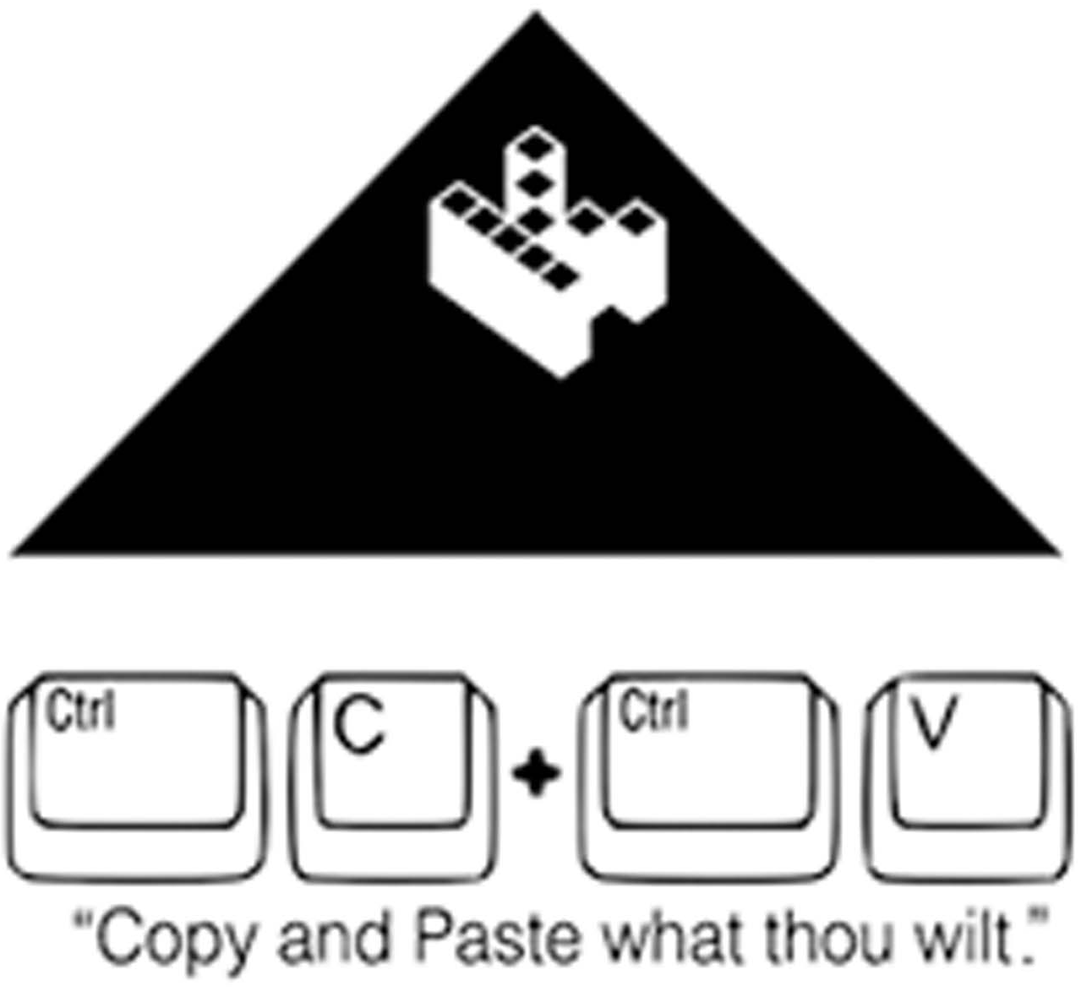

http://infidel2u.org

